Unit: 6 |  |  | “Travel & Holidays”
Teacher name: |  |  | S. Pashkova
Date: |  |  | 28.02.2023
Grade: 6 A |  |  | Number present: |  | Number absent:
Theme of the lesson: |  | Revision “Travel & Holidays”
Learning objectives |  | 6.1.1.1 use speaking and listening skills for creative, collaborative problem solving in groups;  6.3.7.1- use appropriate subject-specific vocabulary and syntax to talk about a limited range of general topics, and some curricular topics
Lesson objectives |  | All learners will be able to:  - use the topical vocabulary to talk about travelling & holiday activities  - use the often named adjectives to describe places of interest & to express personal feelings  Most learners will be able to:  - use the topical vocabulary to talk about travelling & holiday activities  and to name famous sightseeing in Astana & London;  - use adjectives to describe places of interest & to express personal feelings;  - make few sentences with subject vocabulary  Some learners will be able to:  - use adjectives to describe places of interest, to express personal feelings & opinion;  - analyze the key information about the city;  - express own opinion with specific information to talk about the city
Previous learning |  | Writing an email about
Plan
Planned timings | Planned activities |  |  | Learners’ activities |  | Evaluation | Resources
Beginning  5 min | Organizational moment  - Greeting learners.  - Warming up. The Lesson Theme  – Writing ‘Travel wishes ticket’  Instruction:  1. Write down best wishes for your friend.  2. Exchange your ticket with your partner.  - Discussing learning objectives with the learners.  Teacher focuses learners on the main goals and assessment criteria of the lesson.  - Teams divide the class.  - The lesson route.  - Tr explains that after doing each task the teams should assess each other. |  |  | Ss answer the Tr’s questions  Watching the video Ss guess the lesson theme  Ss write down and exchange their tickets  Ls discuss learning objectives.  Each team chooses the leader, gets the nickname. |  | Verbal evaluation  “Guess the theme of the lesson”  “I wish”  “Taking to the wall”  Mutual evaluation of teams | PPT Slides 1-4  https://learn  englishkids.  britishcouncil.  org/grammar-  and-vocabulary  /grammar-chants/  remember-last-summer#  main-content  The Success Ladder Poster  Posters “Team working”  Stickers, Poster  Stikers
Middle  10 min | Task1. Focus on Revision – Vocabulary, Listening & Speaking practice  - Adjectives  - Types of holidays  - Ways of travelling  - Travelling preferences: I like travelling by/on …, because it is  - Holiday activities  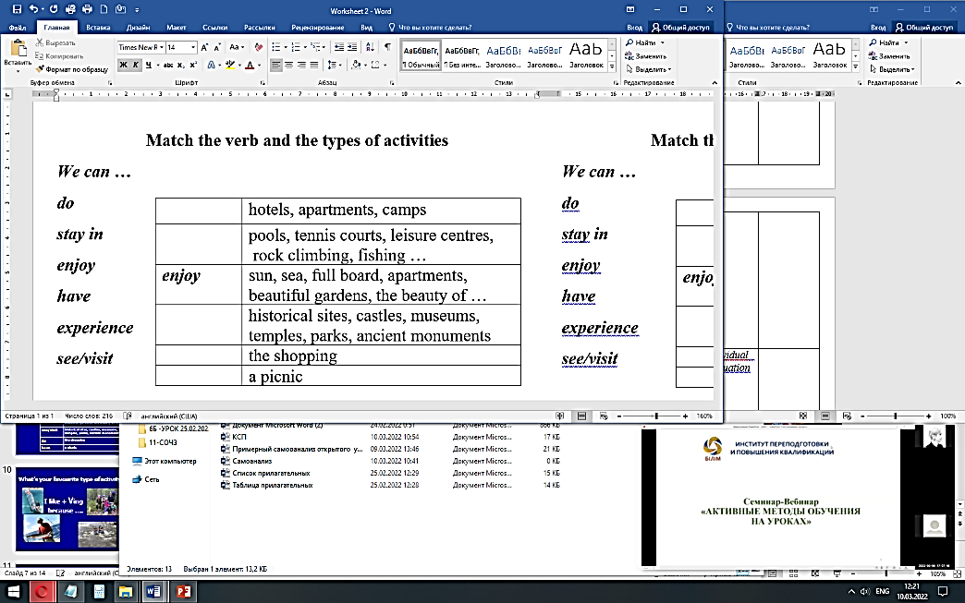  - What’s your favourite type of activity?  Physical Exercises  Task2. Project Work  Preparation: the problem solution suggestion  Tr asks:  - Why is the man stressed?  Tr suggests another way of travelling for the man.  3D reality tours to the capital cities – Astana & London  Scrapbook creation & Presentation.  Supporting questions:  - What is your destination?  - What do you know about the city?  - Are there many attractions in the city? Name them.  - What is the landmark of the city?  - Do you like virtual travelling? Why? Why not?  Task 3. Interactive Quiz  Additional task 4. - Reading  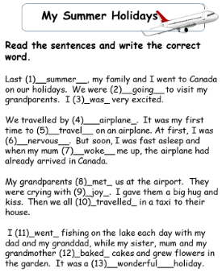 |  |  | Learners revise the adjectives using for describing  Descriptors:1. Match each travelling type to the picture  1. Use the model  2. Complete the sentences with prepositions “by/on”  1. Use the previous  models  2. Complete the  sentences about yourselves.  1. Complete the table  2. Use the model “I like + Ving because ….” Ss to tell about your favourite holiday activities  Instruction:  1. Watch a One Minute video  2. Answer the question  3. Read about the possible solution.  Group working  Descriptors:  1. Watch the 3D tour.  2. Create your 3D tour Scrapbook.  3. Organize your ideas according to the questions.  4. Use adjectives to share your experience and to express your feelings.  5. Present your work in 2-3 minutes  Instruction:  1. Read the text.  2. Choose and write the correct word in each gap. |  | “Give a shake to memory”  “Snowball”  Verbal evaluation  “Pathfinder”  “Collabora -tion”  “Digital Learning” | PPT Slides  5-10  Handout 1  PPT Slide 11  https://www.you  tube.com/watch?v=  SOCme0nkgns  PPT Slides 12,13  https://360.visit  london.com/#  https://truevirtual  tours.com/ru/tour/  astana  www. kahoot.com  Handout 2
End  5 min | Reflection –  Home task:  - Additional Reading task  - Karaoke Song “  Saying goodbye |  |  |  |  | “Five Fin-  gers” Self-assessment | Stickers  Poster  https://www.you  tube.com/watch?  v=sBDJw1gSijI

Assessment criteria:
- Use the topic vocabulary in speech
- Develop speaking skills
- Use speaking and soft skills working in a group

